// 1.Write a program that demonstrates program structure of java with use of arithmetical and logical implementation.

class JavaStruc

{

public static void main(String[] args)

{

int a=10,b=5;

System.out.println("Addition Is : "+(a+b));

System.out.println("Substraction Is : "+(a-b));

System.out.println("Multiplicaton Is : "+(a*b));

System.out.println("Divison Is : "+(a/b));

System .out.println("Modulo Is : "+(a%b));

boolean x=true,y=false;

System.out.println("AND (x&&y) : "+(x&&y));

System.out.println("OR (x||y) : "+(x||y));

System.out.println("Not (!x) : "+(!x));

}

}

/*

Output

Addition Is : 15

Substraction Is : 5

Multiplicaton Is : 50

Divison Is : 2

Modulo Is : 0

AND (x&&y) : false

OR (x||y) : true

Not (!x) : false

Tool completed successfully */

// 2. Write a program that demonstrates string operations using String and StringBuffer class.

class StringsOP

{

public static void main(String[] args)

{

StringBuffer s=new StringBuffer("Hello");

StringBuffer s1=new StringBuffer("Java Programmers");

String s2=s+" "+s1;

System.out.println("Concatenated String Is : "+s2);

System.out.println("Substring of Character 6 to 18 String Is : "+s2.substring(6,18));

System.out.println("Length Of String Is : "+s2.length());

System.out.println("Character At Index 3 Is : "+s2.charAt(3));

}

}

/*

Output

Concatenated String Is : Hello Java Programmers

Substring of Character 6 to 18 String Is : Java Program

Length Of String Is : 22

Character At Index 3 Is : l */

// 3. Write a program to demonstrate inner class and static fields.

class Outer

{

static int count=0;

public Outer()

{

count++;

}

class Inner

{

void display()

{

System.out.println("This Is Inner Class");

}

}

public static void main(String[] args)

{

Outer obj1=new Outer();

Outer obj2=new Outer();

Outer.Inner obj3=obj1.new Inner();

obj3.display();

System.out.println("No. Of Outer Class Objects Created : "+Outer.count);

}

}

/*

Output

This Is Inner Class

No. Of Outer Class Objects Created : 2

Tool completed successfully */

// 4. Write a program that demonstrates inheritance, polymorphism.

class Animal

{

void Sound()

{

System.out.println("Animal Makes A Sound");

}

}

class Dog extends Animal

{

void Sound()

{

System.out.println("Dog Barks ");

}

}

class Cat extends Animal

{

void Sound()

{

System.out.println("Cat Meows ");

}

}

class IPExam

{

public static void main(String[] args)

{

Animal A=new Animal();

Animal B=new Dog();

Animal C=new Cat();

A.Sound();

B.Sound();

C.Sound();

}

}

/*

Output

Animal Makes A Sound

Dog Barks

Cat Meows

Tool completed successfully /*

// 5. Write a program that demonstrates 2D shapes on frames.

import javax.swing.*;

import java.awt.*;

class shapes extends JPanel

{

public void paint(Graphics g)

{

g.setColor(Color.RED);

g.drawRect(20,20,80,75);

g.drawLine(20,20,100,95);

g.drawLine(100,20,20,95);

g.drawOval(20,20,80,76);

}

public static void main(String[] args)

{

JFrame F=new JFrame();

F.setTitle("Simple 2D Shapes");

F.setSize(300,300);

F.setDefaultCloseOperation(JFrame.EXIT_ON_CLOSE);

F.add(new shapes());

F.setVisible(true);

}

}

/*

Output

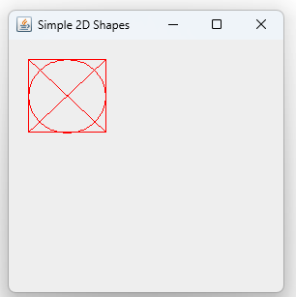

// 6. Write a program that demonstrates color and fonts.

import javax.swing.*;

import java.awt.*;

class CFDemo extends JPanel

{

public void paint(Graphics g)

{

g.setFont(new Font("Serif",Font.BOLD,24));

g.setColor(Color.RED);

g.drawString("This Is RED Colour",50,50);

g.setColor(Color.YELLOW);

g.drawString("This Is YELLOW Colour",50,80);

g.setColor(Color.ORANGE);

g.drawString("This Is ORANGE Colour",50,110);

g.setColor(Color.BLACK);

g.drawString("This Is BLACK Colour",50,140);

}

public static void main(String[] args)

{

JFrame J=new JFrame();

J.setTitle("Colour And Font Demo");

J.setSize(300,300);

J.setDefaultCloseOperation(JFrame.EXIT_ON_CLOSE);

J.add(new CFDemo());

J.setVisible(true);

}

}

/*

Output

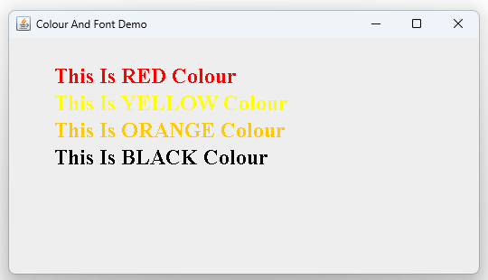

// 7. Write a program to illustrate the use of various swing components.

import javax.swing.*;

import java.awt.*;

import java.awt.event.ActionEvent;

import java.awt.event.ActionListener;

public class SwingComponentsDemo extends JFrame

{

public SwingComponentsDemo()

{

setTitle("Swing Components Example");

setSize(300,300);

setDefaultCloseOperation(JFrame.EXIT_ON_CLOSE);

setLayout(new FlowLayout());

JLabel label = new JLabel("Enter your name:");

add(label);

JTextField textField = new JTextField(20);

add(textField);

JCheckBox checkBox = new JCheckBox("I agree to terms");

add(checkBox);

JRadioButton maleButton = new JRadioButton("Male");

JRadioButton femaleButton = new JRadioButton("Female");

ButtonGroup genderGroup = new ButtonGroup();

genderGroup.add(maleButton);

genderGroup.add(femaleButton);

add(maleButton);

add(femaleButton);

String[] countries = {"India", "USA", "UK", "Canada"};

JComboBox<String> comboBox = new JComboBox<>(countries);

add(comboBox);

JButton button = new JButton("Submit");

add(button);

button.addActionListener(new ActionListener()

{

public void actionPerformed(ActionEvent e)

{

String name = textField.getText();

String country = (String) comboBox.getSelectedItem();

JOptionPane.showMessageDialog(null, "Hello " + name + " from " + country);

}

});

setVisible(true);

}

public static void main(String[] args)

{

new SwingComponentsDemo();

}

}

/*

Output

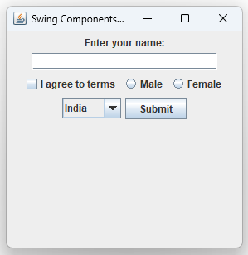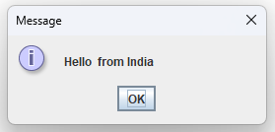

// 8. Write a program that demonstrates use of dialog box and menus.

import javax.swing.*;

import java.awt.*;

import java.awt.event.*;

class MenuFrame extends JFrame

{

public MenuFrame()

{

setTitle("Menu Demo");

setSize(500,400);

}

}

public class menu

{

public static void main(String args[])

{

MenuFrame frame=new MenuFrame();

JMenuBar mb=new JMenuBar();

frame.setJMenuBar(mb);

JMenu fileMenu=new JMenu("File");

JMenuItem newItem=new JMenuItem("New");

JMenuItem openItem=new JMenuItem("Open");

JMenuItem saveItem=new JMenuItem("Save");

fileMenu.add(newItem);

fileMenu.add(openItem);

fileMenu.add(saveItem);

fileMenu.addSeparator();

JMenu editMenu=new JMenu("Edit");

JMenuItem cutItem=new JMenuItem("Cut");

JMenuItem copyItem=new JMenuItem("Copy");

JMenuItem pasteItem=new JMenuItem("Paste");

editMenu.add(cutItem);

editMenu.add(copyItem);

editMenu.add(pasteItem);

mb.add(fileMenu);

mb.add(editMenu);

frame.setDefaultCloseOperation(JFrame.EXIT_ON_CLOSE);

frame.setVisible(true);

}

}

/*

Output

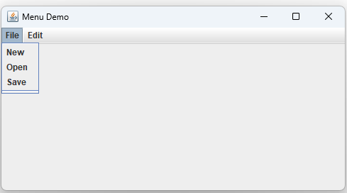

// 9. Write a program that demonstrates event handling for various types of events.

//Program to Demonstrate Window Events.

import java.awt.*;

import java.awt.event.*;

import javax.swing.*;

class WindowFrame extends JFrame implements WindowListener

{

public WindowFrame()

{

setTitle("Window Test");

setSize(300,200);

addWindowListener(this);

}

public void windowClosing(WindowEvent e)

{

System.out.println("Window is closing");

}

public void windowOpened (WindowEvent e)

{

System.out.println("Window is opened");

}

public void windowIconified (WindowEvent e)

{

System.out.println("Window is iconified");

}

public void windowDeiconified(WindowEvent e)

{

System.out.println("Window is deiconified");

}

public void windowClosed(WindowEvent e)

{

System.out.println("Window is closed");

}

public void windowActivated(WindowEvent e)

{

System.out.println("Window id activated");

}

public void windowDeactivated(WindowEvent e)

{

System.out.println("Window is deactivated");

}

}

public class window

{

public static void main(String args[])

{

WindowFrame f=new WindowFrame();

f.setDefaultCloseOperation(JFrame.EXIT_ON_CLOSE);

f.setVisible(true);

}

}

/*

Output

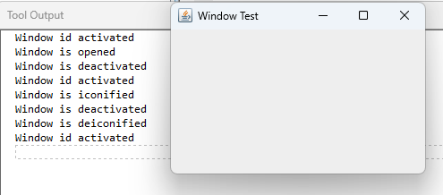

//Program to Demonstrate Keyboard Events.

import java.awt.*;

import java.awt.event.*;

import javax.swing.*;

class KeyFrame extends JFrame implements KeyListener

{

public KeyFrame(){

setTitle("Sketch Frame");

setSize(300,350);

addKeyListener(this);

}

public void keyPressed(KeyEvent evt)

{

System.out.println("Key Pressed by user");

}

public void keyReleased(KeyEvent evt)

{

System.out.println("Key Released by user");

}

public void keyTyped(KeyEvent evt)

{

System.out.println("Key typed by user");

}

}

public class key

{

public static void main(String[]args)

{

JFrame frame=new KeyFrame();

frame.setDefaultCloseOperation(JFrame.EXIT_ON_CLOSE);

frame.setVisible(true);

}

}

/*

Output

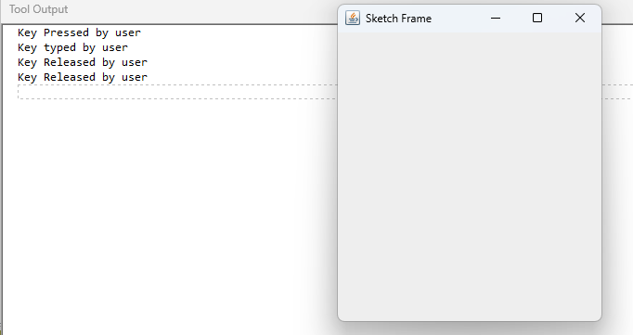

//Program in Java to Demonstrate Mouse Events.

import java.awt.*;

import java.awt.event.*;

public class mouse extends Frame implements MouseListener

{

Label l;

mouse()

{

addMouseListener(this);

l=new Label();

l.setBounds(20,50,100,20);

add(l);

setTitle("Mouse event");

setSize(300,300);

setLayout(null);

setVisible(true);

}

public void mouseClicked(MouseEvent e)

{

System.out.println("Mouse Clicked");

}

public void mouseEntered(MouseEvent e)

{

System.out.println("Mouse Entered");

}

public void mouseExited (MouseEvent e)

{

System.out.println("Mouse Exited");

}

public void mousePressed (MouseEvent e)

{

System.out.println("Mouse Pressed");

}

public void mouseReleased(MouseEvent e)

{

System.out.println("Mouse Released");

}

public static void main(String[] args)

{

new mouse();

}

}

/*

Output

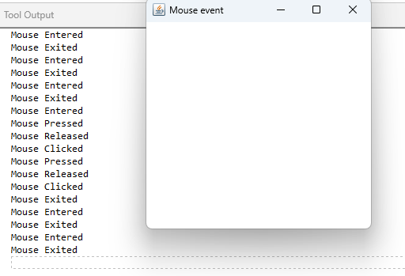

// 10. Write a program to illustrate multithreading.

class DemoThread extends Thread

{

public void run()

{

for (int i=1;i<=100;i++)

{

System.out.print(i+"\t");

}

}

public static void main(String[] args)

{

DemoThread D=new DemoThread();

Thread T=new Thread(D);

DemoThread D1=new DemoThread();

Thread T1=new Thread(D1);

T.start();

T1.start();

}

}

/*

Output

1 2 3 4 5 6 7 8 9 10 11 12 13 14 15 16 17 18 19 20 21 22 23 24 25 26 27 28 29 30 31 32 33 34 35 36 37 38 39 40 41 42 43 44 45 46 47 48 49 50 51 52 53 54 55 56 57 58 59 60 61 62 63 64 65 66 67 68 69 70 71 72 73 74 75 76 77 78 79 80 81 82 83 84 85 86 87 88 89 90 91 92 93 94 95 96 97 98 99 100 1 2 3 4 5 6 7 8 9 10 11 12 13 14 15 16 17 18 19 20 21 22 23 24 25 26 27 28 29 30 31 32 33 34 35 36 37 38 39 40 41 42 43 44 45 46 47 48 49 50 51 52 53 54 55 56 57 58 59 60 61 62 63 64 65 66 67 68 69 70 71 72 73 74 75 76 77 78 79 80 81 82 83 84 85 86 87 88 89 90 91 92 93 94 95 96 97 98 99 100

Tool completed successfully */

// 11.Write a program to illustrate exception handling.

import java.util.*;

class Excep extends Exception

{

public static void main(String[] args)

{

Scanner s=new Scanner(System.in);

System.out.println("Enter The 1st Number For Division");

int a=s.nextInt();

System.out.println("Enter The 2nd Number For Division");

int b=s.nextInt();

try

{

int c=a/b;

System.out.println("Result Is : "+c);

}

catch(Exception e)

{

System.out.println("Cannot Divide By Zero");

}

}

}

/*

Output  
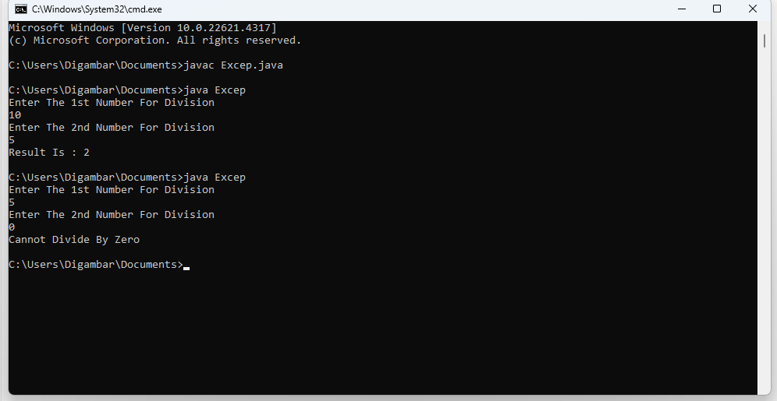

// 12.Write a program to demonstrate the use of File class.

import java.io.*;

class FileDemo

{

public static void main(String[] args) throws IOException

{

File file = new File("test.txt");

file.createNewFile();

FileWriter writer = new FileWriter(file);

writer.write("Hello, File Handling!");

writer.close();

BufferedReader reader = new BufferedReader(new FileReader(file));

System.out.println("File Content: " + reader.readLine());

reader.close();

file.delete();

}

}

/*

Output

File Content: Hello, File Handling!

Tool completed successfully */

// 13.Write a program that demonstrates JDBC on application.

// 14.Write a program that demonstrate package creation and use in program.

package calculator;

public class Calculator

{

public int add(int a, int b)

{

return a+b;

}

public int subtract(int a, int b)

{

return a-b;

}

public int multiple(int a, int b)

{

return a*b;

}

public int divide(int a,int b)

{

return a/b;

}

}

----------------------------------------------------------------------------------------------------------------

import calculator.Calculator;

public class arith

{

public static void main(String[] args)

{

Calculator cal = new Calculator();

int num1 = 10;

int num2 = 5;

System.out.println("Sum is: " + cal.add(p,q));

System.out.println("Subtraction is: " + cal.subtract(p,q));

System.out.println("Multiplication is: " + cal.multiply(p,q));

System.out.println("Division is: " + cal.divide(p,q));

}

}

/*

Output

Sum is: 15

Subtraction is: 5

Multiplication is: 50

Division is: 2

Tool completed successfully */